Sprint 1 Plan

Pix Paint

Blair O’Brien, Daniel Phelps, Likha Pulido, Jennifer Chen, Christy Miao

Revision: 2

Revision Date: 4/22/2024

Completion Date: 4/23/2024

# Goals

* Computer executable
* Have a familiar, intuitive GUI.
* Canvas presence (100 x 100 px)
* File opening functionality
* File saving functionality
* Single-pixel pen/pencil tool
* Single-pixel eraser tool

# Tasks

* User-story 1: As a program-user, I want to use Pix Paint as an offline/online application.
  + Task 1: Make github repo
  + Task 2: Research what tech to use
  + Task 3: Setup environment, folders, files etc
  + Task 4: Create a basic exe that opens a window
  + Task 5: Make GUI
* User-story 2: As a program-user, I want to create/open/save/export a canvas that can have its dimensions set before/after creation.).
  + Task 1: Research how to make a canvas, save canvas in different formats and resolutions, how to restore it
  + Task 2: Implement canvas and creating/saving/opening/exporting functionality
* User-story 3: As a program-user, I want to use pen and eraser tools that can have their sizes/opacities adjusted.
  + Task 1: Research
  + Task 2: Implementation

# Team Roles

* Blair O’Brien: Project Owner/ Team Member Product Owner
* Daniel Phelps: Scrum Master/ Team Member
* Likha Pulido: Team Member
* Jennifer Chen: Team Member
* Christy Miao: Team Member

# Task Assignment

* Blair O’Brien:
  + User-story 1: Research what tech to use
  + User-story 1: Make github repo
  + User-story 1: Setup environment, folders, files etc
  + User-story 1: Make basic exe that opens a window
* Daniel Phelps:
  + User-story 1: Research what tech to use
  + User-story 3: Research/ implement how to make canvas
* Likha Pulido:
  + User-story 1: Research what tech to use
  + User-story 1: Make GUI
* Jennifer Chen:
  + User-story 1: Research what tech to use
  + User-story 2: implement pen/eraser functionality
* Christy Miao: User-story 1, Research what tech to use
  + User-story 1: Research what tech to use
  + User-story 3: research/implement save functionality

# Burnup Chart

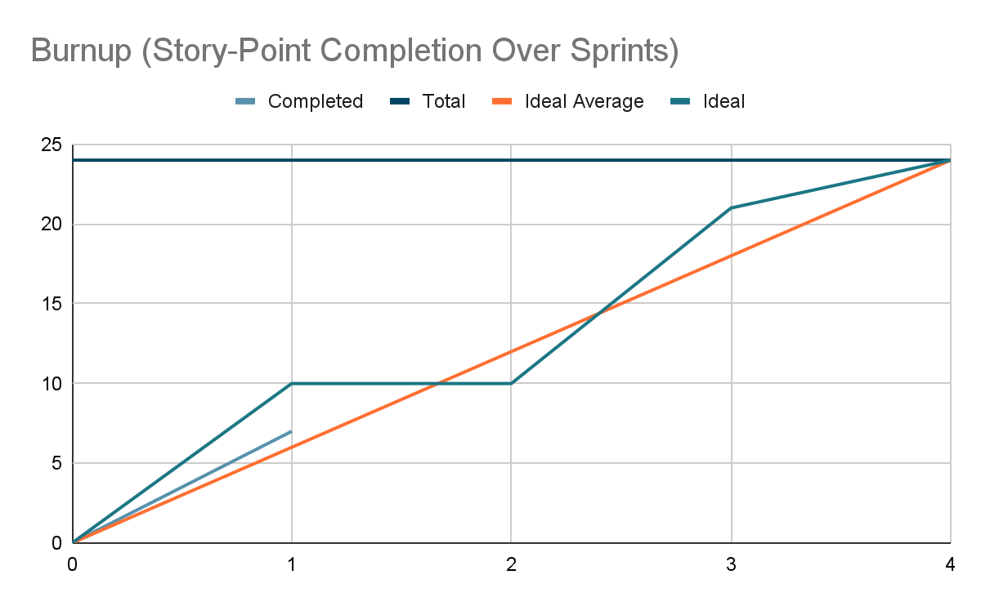

# Scrum Board

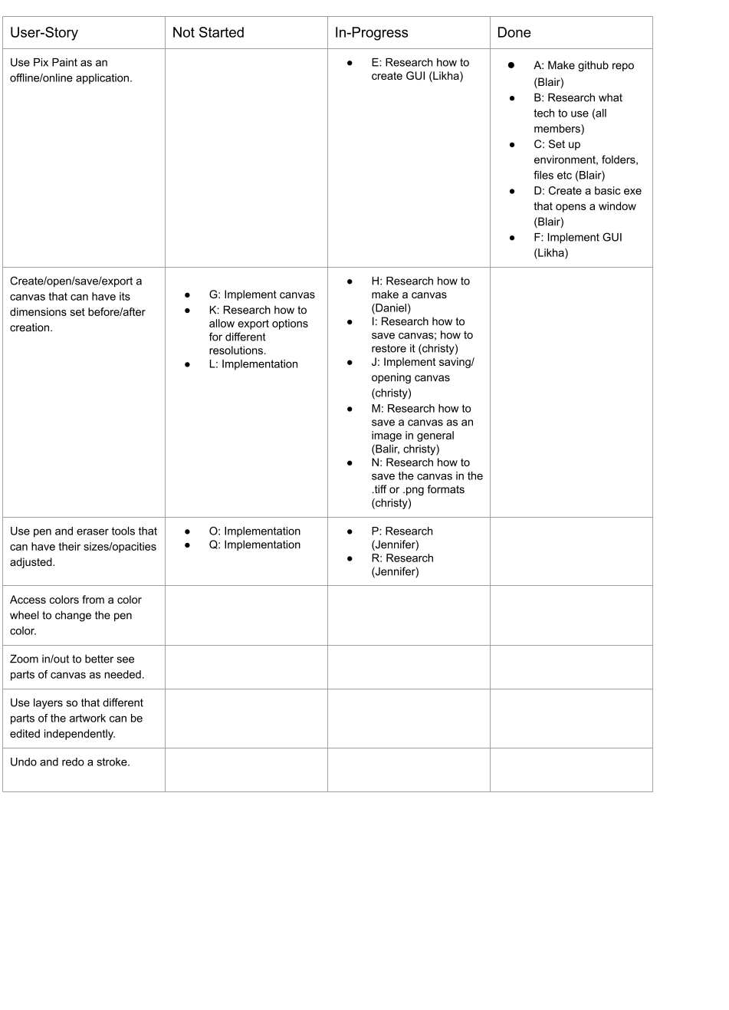

# Scrum Times

| Day | Time |
| --- | --- |
| Monday (SCRUM meeting) | 1:30 PM - 1:45 PM |
| Wednesday (SCRUM meeting) | 1:30 PM - 1:45 PM |
| Thursday (meeting with TA) | 9:00 AM - 10:00 AM |
| Thursday (Development meeting) | 10:30 AM - 11:30 AM |
| Friday (SCRUM meeting) | 1:30 PM - 1:45 PM |
| Sunday (Development meeting) | 10:30 AM - 11:30 AM |